Supplementary Figure 1: Receiver Operating Curves and FIT starting age distribution (based on a mean starting age of 60) for each risk score, based on assessing 10-year risk at age 40.
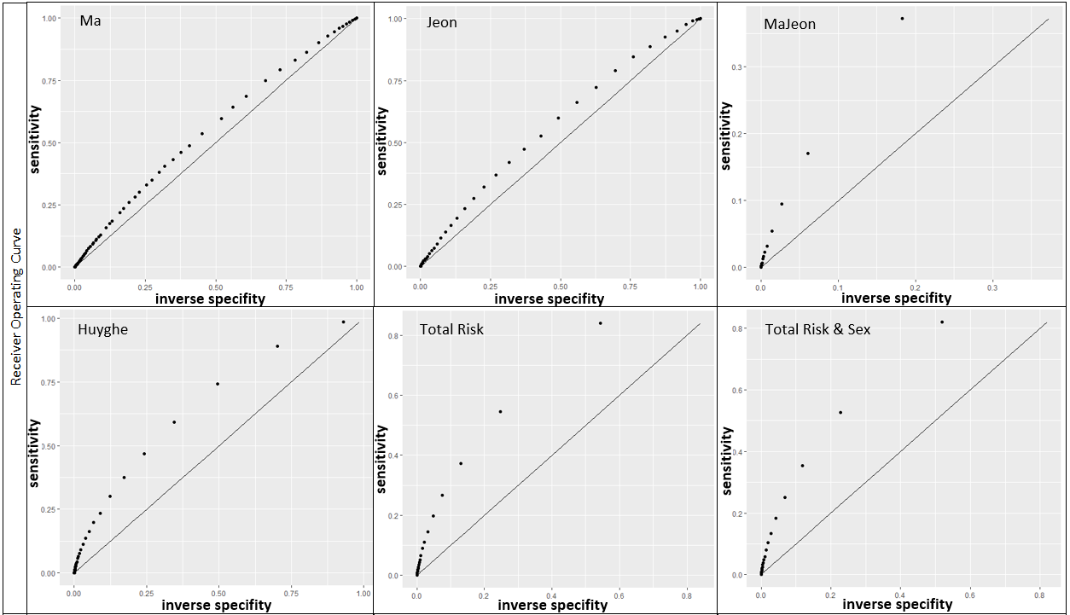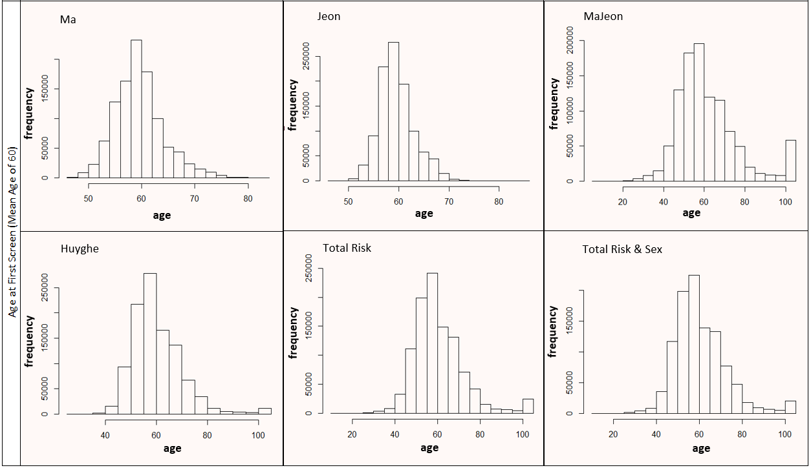

Supplementary Figure 2: Incremental outcomes for risk-stratification (based on a mean screening start age of 50), compared to screening start age of 50 for the entire population using FIT120. Incremental net monetary benefit is based on a cost-effectiveness threshold of £20,000/QALY.
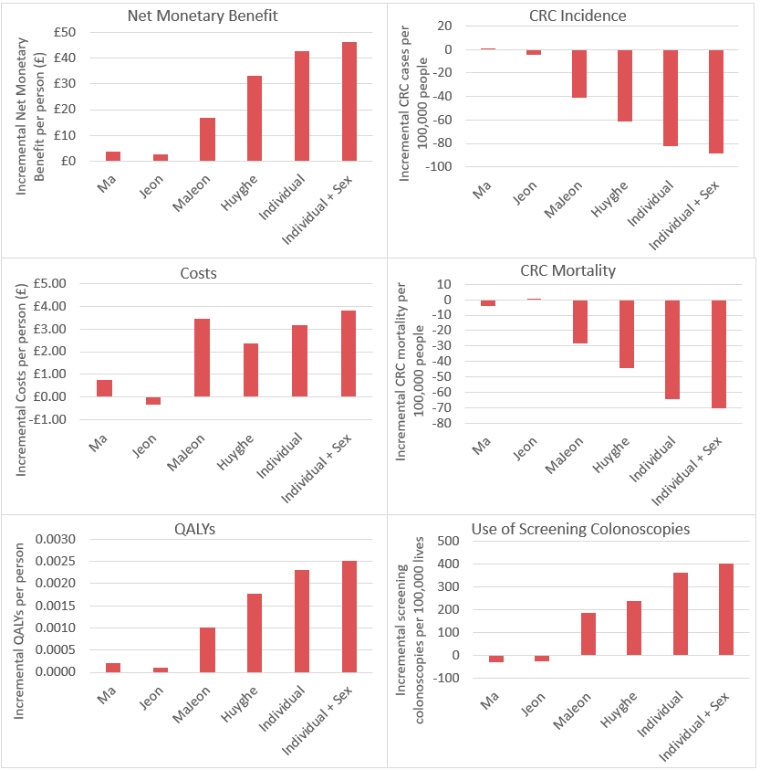

Supplementary Figure 3: Incremental outcomes for risk-stratification (based on a mean screening start age of 60), compared to screening start age of 60 for the entire population using FIT20. Incremental net monetary benefit is based on a cost-effectiveness threshold of £20,000/QALY.
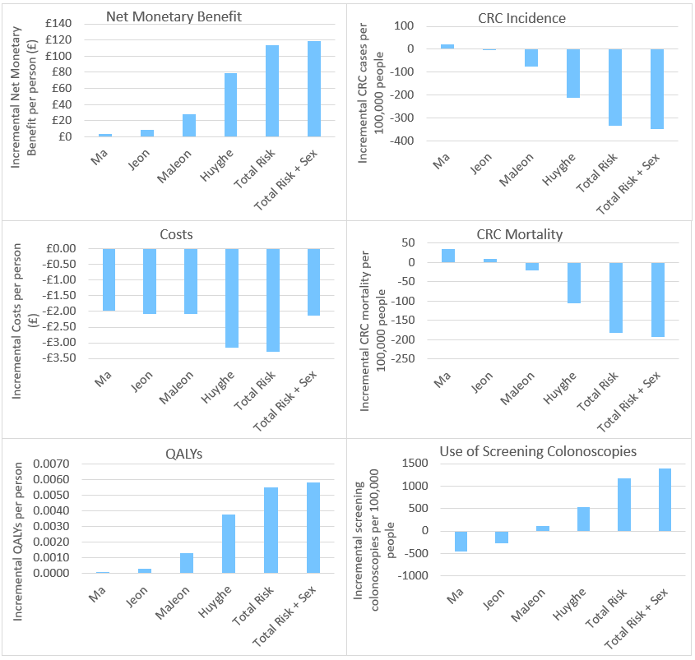

Supplementary Table 1: Values used in the model for FIT sensitivity and specificity (first round of screening).
FIT Threshold | Age | Sex | Sensitivity to CRC | Sensitivity to High Risk Adenoma | Sensitivity to Low Risk Adenoma | Specificity
FIT120 | 60 | Male | 0.354 | 0.104 | 0.020 | 0.996
 |  | Female | 0.156 | 0.085 | 0.011 | 0.997
 | 50 | Male | 0.356 | 0.080 | 0.014 | 0.998
 |  | Female | 0.144 | 0.074 | 0.008 | 0.998
FIT20 | 60 | Male | 0.410 | 0.249 | 0.080 | 0.976
 |  | Female | 0.211 | 0.229 | 0.049 | 0.979
FIT Faecal Immunochemical Test; CRC Colorectal Cancer

Supplementary Table 2: Full set of incremental outcomes for risk-stratification based on a mean FIT120 screening start age of 50, compared to screening everyone with FIT120 at age 50.
Risk Score |  | Ma | Jeon | MaJeon | Huyghe | Total Risk | Total Risk + Sex
Total Costs per person | M | £0.78 | -£0.34 | £3.46 | £2.35 | £3.15 | £3.82
 | L | -£19 | -£21 | -£16 | -£20 | -£20 | -£20
 | U | £20 | £19 | £26 | £26 | £27 | £27
CRC Treatment Costs per person | M | £0.54 | -£0.49 | -£1.23 | -£1.87 | -£2.51 | -£2.38
 | L | -£20 | -£23 | -£23 | -£26 | -£27 | -£28
 | U | £20 | £20 | £22 | £21 | £23 | £23
Screen & Surveillance Costs per person | M | £0.23 | £0.15 | £4.69 | £4.22 | £5.67 | £6.20
 | L | -£5 | -£5 | -£1 | -£1 | £0 | £0
 | U | £5 | £5 | £10 | £10 | £12 | £13
QALYs per person | M | 0.0002 | 0.0001 | 0.0010 | 0.0018 | 0.0023 | 0.0025
 | L | -0.0048 | -0.0043 | -0.0044 | -0.0036 | -0.0038 | -0.0035
 | U | 0.0050 | 0.0045 | 0.0059 | 0.0075 | 0.0087 | 0.0090
NMB per person (£20,000/QALY Threshold) | M | £3.53 | £2.48 | £16.91 | £33.15 | £42.79 | £46.32
 | L | -£91 | -£86 | -£88 | -£75 | -£75 | -£68
 | U | £96 | £90 | £112 | £140 | £171 | £180
NMB per person (£30,000/QALY Threshold) | M | £5.68 | £3.55 | £27.10 | £50.90 | £65.76 | £71.38
 | L | -£139 | -£129 | -£133 | -£118 | -£110 | -£109
 | U | £149 | £136 | £172 | £209 | £257 | £269
MJC per person (£20,000/QALY Threshold) | M | £4.98 | £3.50 | £23.86 | £46.76 | £60.36 | £65.33
 | L | -£129 | -£121 | -£124 | -£106 | -£106 | -£96
 | U | £136 | £127 | £158 | £198 | £241 | £253
MJC per person (£30,000/QALY Threshold) | M | £8.01 | £5.00 | £38.23 | £71.80 | £92.76 | £100.69
 | L | -£196 | -£182 | -£187 | -£167 | -£155 | -£153
 | U | £210 | £192 | £243 | £295 | £363 | £380
Prob. cost-effective (£20,000/QALY) |  | 53% | 53% | 64% | 73% | 75% | 78%
Prob. cost-effective (£30,000/QALY) |  | 53% | 52% | 66% | 74% | 75% | 78%
CRC Incidence per 100,000 people | M | 1 | -5 | -41 | -61 | -83 | -89
 | L | -1106 | -1098 | -1201 | -1242 | -1324 | -1363
 | U | 1092 | 1050 | 1082 | 1121 | 1157 | 1165
CRC Mortality per 100,000 people | M | -4 | 0 | -28 | -44 | -64 | -70
 | L | -483 | -462 | -518 | -560 | -616 | -611
 | U | 460 | 458 | 450 | 456 | 471 | 460
FIT screening invites per person | M | -0.035 | -0.031 | 0.572 | 0.044 | 0.012 | 0.035
 | L | -0.058 | -0.055 | 0.546 | 0.006 | -0.091 | -0.072
 | U | -0.012 | -0.008 | 0.596 | 0.082 | 0.093 | 0.125
Screening colonoscopies per 100,000 people | M | -28 | -26 | 188 | 237 | 360 | 403
 | L | -785 | -782 | -485 | -517 | -458 | -362
 | U | 723 | 728 | 916 | 1019 | 1206 | 1272
QALY Quality Adjusted Life Year; NMB Net Monetary Benefit; MJC Maximum Justifiable Cost (of risk scoring procedure); CRC Colorectal Cancer; FIT Faecal Immunochemical Test; Prob. Probability; M Mean; L Lower 95% credible interval; U Upper 95% credible interval.

Supplementary Table 3: Full set of incremental outcomes for risk-stratification based on a mean FIT20 screening start age of 60, compared to screening everyone with FIT20 at age 60.
Risk Score |  | Ma | Jeon | MaJeon | Huyghe | Total Risk | Total Risk + Sex
Total Costs per person | M | -£1.96 | -£2.07 | -£2.08 | -£3.15 | -£3.29 | -£2.13
 | L | -£23 | -£20 | -£23 | -£26 | -£25 | -£26
 | U | £17 | £15 | £16 | £18 | £20 | £21
CRC Treatment Costs per person | M | -£2.78 | -£2.67 | -£7.46 | -£14.36 | -£20.08 | -£20.48
 | L | -£24 | -£22 | -£30 | -£40 | -£44 | -£47
 | U | £17 | £16 | £12 | £8 | £4 | £5
Screen & Surveillance Costs per person | M | £0.82 | £0.60 | £5.37 | £11.22 | £16.79 | £18.36
 | L | -£5 | -£5 | £0 | £5 | £9 | £11
 | U | £6 | £6 | £12 | £18 | £25 | £28
QALYs per person | M | 0.0001 | 0.0003 | 0.0013 | 0.0038 | 0.0055 | 0.0058
 | L | -0.0043 | -0.0037 | -0.0029 | -0.0007 | 0.0004 | 0.0007
 | U | 0.0041 | 0.0041 | 0.0057 | 0.0091 | 0.0113 | 0.0118
NMB per person (£20,000/QALY Threshold) | M | £3.77 | £8.36 | £28.10 | £79.03 | £113.32 | £118.45
 | L | -£78 | -£73 | -£57 | -£14 | £11 | £20
 | U | £86 | £86 | £117 | £181 | £225 | £233
NMB per person (£30,000/QALY Threshold) | M | £4.68 | £11.50 | £41.11 | £116.97 | £168.33 | £176.60
 | L | -£120 | -£109 | -£87 | -£17 | £16 | £30
 | U | £127 | £126 | £172 | £271 | £336 | £357
MJC per person (£20,000/QALY Threshold) | M | £5.32 | £11.79 | £39.64 | £111.48 | £159.85 | £167.08
 | L | -£110 | -£103 | -£81 | -£20 | £16 | £28
 | U | £121 | £121 | £165 | £256 | £317 | £329
MJC per person (£30,000/QALY Threshold) | M | £6.59 | £16.22 | £58.00 | £165.00 | £237.45 | £249.12
 | L | -£169 | -£154 | -£123 | -£24 | £22 | £43
 | U | £179 | £177 | £243 | £382 | £474 | £503
Prob. cost-effective (£20,000/QALY) |  | 54% | 57% | 74% | 95% | 99% | 99%
Prob. cost-effective (£30,000/QALY) |  | 53% | 57% | 74% | 94% | 99% | 98%
CRC Incidence per 100,000 people | M | 20 | -3 | -75 | -212 | -335 | -347
 | L | -1147 | -1104 | -1271 | -1445 | -1614 | -1605
 | U | 1210 | 1145 | 1090 | 984 | 923 | 886
CRC Mortality per 100,000 people | M | 34 | 10 | -21 | -106 | -182 | -193
 | L | -480 | -469 | -536 | -622 | -709 | -733
 | U | 582 | 524 | 500 | 420 | 351 | 328
FIT screening invites per person | M | 0.016 | -0.024 | 0.253 | 0.020 | 0.027 | 0.049
 | L | -0.011 | -0.050 | 0.224 | -0.022 | -0.040 | -0.018
 | U | 0.043 | 0.002 | 0.283 | 0.061 | 0.088 | 0.112
Screening colonoscopies per 100,000 people | M | -457 | -274 | 119 | 526 | 1166 | 1397
 | L | -1536 | -1339 | -1006 | -762 | -107 | 137
 | U | 718 | 858 | 1302 | 1798 | 2448 | 2722
QALY Quality Adjusted Life Year; NMB Net Monetary Benefit; MJC Maximum Justifiable Cost (of risk scoring procedure); CRC Colorectal Cancer; FIT Faecal Immunochemical Test; Prob. Probability; M Mean; L Lower 95% credible interval; U Upper 95% credible interval.

Supplementary Table 4: Full set of incremental outcomes for a scenario in which screening uptake is reduced by 25%. Risk-stratification based on a mean FIT120 screening start age of 60 is compared to screening everyone with FIT120 at age 60.
Risk Score |  | Ma | Jeon | MaJeon | Huyghe | Total Risk | Total Risk + Sex
Total Costs per person | M | -£1.97 | -£1.82 | -£1.24 | -£0.03 | £2.00 | £2.52
 | L | -£17 | -£17 | -£16 | -£16 | -£16 | -£15
 | U | £13 | £13 | £14 | £16 | £20 | £22
CRC Treatment Costs per person | M | -£2.11 | -£1.58 | -£2.44 | -£4.91 | -£5.38 | -£5.69
 | L | -£18 | -£17 | -£18 | -£22 | -£24 | -£25
 | U | £14 | £14 | £13 | £12 | £13 | £14
Screen & Surveillance Costs per person | M | £0.14 | -£0.24 | £1.19 | £4.88 | £7.38 | £8.21
 | L | -£3 | -£4 | -£2 | £1 | £3 | £4
 | U | £4 | £3 | £5 | £9 | £12 | £14
QALYs per person | M | 0.0000 | 0.0001 | 0.0004 | 0.0019 | 0.0028 | 0.0031
 | L | -0.0033 | -0.0031 | -0.0030 | -0.0017 | -0.0011 | -0.0008
 | U | 0.0033 | 0.0033 | 0.0038 | 0.0060 | 0.0077 | 0.0078
NMB per person (£20,000/QALY Threshold) | M | £1.33 | £3.80 | £9.74 | £37.75 | £54.60 | £59.20
 | L | -£61 | -£55 | -£56 | -£31 | -£21 | -£14
 | U | £68 | £68 | £77 | £119 | £146 | £150
NMB per person (£30,000/QALY Threshold) | M | £1.01 | £4.78 | £13.98 | £56.61 | £82.90 | £90.06
 | L | -£91 | -£86 | -£82 | -£50 | -£31 | -£20
 | U | £101 | £102 | £115 | £179 | £224 | £232
MJC per person (£20,000/QALY Threshold) | M | £1.87 | £5.36 | £13.73 | £53.25 | £77.02 | £83.51
 | L | -£86 | -£77 | -£79 | -£43 | -£29 | -£19
 | U | £95 | £96 | £109 | £168 | £206 | £211
MJC per person (£30,000/QALY Threshold) | M | £1.42 | £6.75 | £19.72 | £79.85 | £116.94 | £127.04
 | L | -£128 | -£122 | -£116 | -£70 | -£43 | -£28
 | U | £142 | £144 | £162 | £252 | £315 | £327
Prob. cost-effective (£20,000/QALY) |  | 50% | 54% | 61% | 86% | 93% | 93%
Prob. cost-effective (£30,000/QALY) |  | 50% | 54% | 61% | 87% | 93% | 93%
CRC Incidence per 100,000 people | M | 6 | 3 | -13 | -102 | -147 | -163
 | L | -978 | -932 | -1010 | -1121 | -1236 | -1228
 | U | 995 | 971 | 979 | 895 | 909 | 877
CRC Mortality per 100,000 people | M | 30 | 21 | 12 | -56 | -102 | -115
 | L | -405 | -394 | -411 | -498 | -553 | -579
 | U | 458 | 426 | 438 | 384 | 329 | 344
FIT screening invites per person | M | -0.176 | -0.221 | -0.160 | -0.139 | -0.115 | -0.081
 | L | -0.200 | -0.239 | -0.186 | -0.173 | -0.177 | -0.146
 | U | -0.154 | -0.200 | -0.132 | -0.103 | -0.053 | -0.020
Screening colonoscopies per 100,000 people | M | -229 | -200 | -134 | 228 | 489 | 601
 | L | -807 | -779 | -725 | -412 | -187 | -55
 | U | 365 | 357 | 473 | 933 | 1161 | 1289
QALY Quality Adjusted Life Year; NMB Net Monetary Benefit; MJC Maximum Justifiable Cost (of risk scoring procedure); CRC Colorectal Cancer; FIT Faecal Immunochemical Test; Prob. Probability; M Mean; L Lower 95% credible interval; U Upper 95% credible interval.

Supplementary Table 5: Incremental cost-effectiveness outcomes for risk-stratification based on a mean FIT120 screening start age of 60, compared to screening everyone with FIT120 at age 60, using a discount rate of 1.5%. Note that clinical and resource use outcomes are not discounted so are identical to those shown in Table 2 of the main results.
Risk Score |  | Ma | Jeon | MaJeon | Huyghe | Total Risk | Total Risk + Sex
Total Costs per person | M | -£1.42 | -£1.24 | -£0.68 | £1.24 | £3.00 | £3.64
 | L | -£11 | -£11 | -£10 | -£9 | -£9 | -£8
 | U | £8 | £8 | £9 | £12 | £15 | £16
CRC Treatment Costs per person | M | -£1.79 | -£1.27 | -£2.01 | -£3.26 | -£3.73 | -£3.82
 | L | -£12 | -£11 | -£12 | -£14 | -£16 | -£16
 | U | £8 | £9 | £8 | £8 | £9 | £8
Screen & Surveillance Costs per person | M | £0.37 | £0.03 | £1.33 | £4.51 | £6.72 | £7.46
 | L | -£2 | -£2 | -£1 | £2 | £3 | £4
 | U | £3 | £2 | £4 | £8 | £10 | £12
QALYs per person | M | 0.0000 | 0.0001 | 0.0003 | 0.0013 | 0.0020 | 0.0022
 | L | -0.0018 | -0.0016 | -0.0015 | -0.0007 | -0.0002 | -0.0003
 | U | 0.0019 | 0.0019 | 0.0023 | 0.0037 | 0.0048 | 0.0048
NMB per person (£20,000/QALY Threshold) | M | £1.01 | £2.70 | £7.00 | £25.31 | £36.62 | £39.69
 | L | -£33 | -£30 | -£29 | -£16 | -£9 | -£5
 | U | £39 | £37 | £49 | £69 | £91 | £91
NMB per person (£30,000/QALY Threshold) | M | £0.81 | £3.42 | £10.16 | £38.59 | £56.43 | £61.36
 | L | -£49 | -£45 | -£42 | -£23 | -£10 | -£6
 | U | £58 | £53 | £71 | £106 | £140 | £139
MJC per person (£20,000/QALY Threshold) | M | £1.65 | £4.39 | £11.41 | £41.23 | £59.66 | £64.66
 | L | -£54 | -£49 | -£47 | -£27 | -£15 | -£9
 | U | £63 | £61 | £79 | £112 | £148 | £148
MJC per person (£30,000/QALY Threshold) | M | £1.32 | £5.58 | £16.56 | £62.85 | £91.93 | £99.95
 | L | -£80 | -£74 | -£68 | -£38 | -£16 | -£10
 | U | £94 | £87 | £115 | £173 | £229 | £226
Prob cost-effective (£20,000/QALY) |  | 50% | 56% | 63% | 88% | 95% | 95%
Prob cost-effective (£30,000/QALY) |  | 49% | 56% | 62% | 88% | 95% | 95%
QALY Quality Adjusted Life Year; NMB Net Monetary Benefit; MJC Maximum Justifiable Cost (of risk scoring procedure); CRC Colorectal Cancer; FIT Faecal Immunochemical Test; Prob. Probability; M Mean; L Lower 95% credible interval; U Upper 95% credible interval.

Supplementary Table 6: Incremental cost-effectiveness outcomes for risk-stratification based on a mean FIT120 screening start age of 60, compared to screening everyone with FIT120 at age 60, using a discount rate of 5%. Note that clinical and resource use outcomes are not discounted so are identical to those shown in Table 2 of the main results.
Risk Score |  | Ma | Jeon | MaJeon | Huyghe | Total Risk | Total Risk + Sex
Total Costs per person | M | -£8.19 | -£6.54 | -£8.18 | -£10.16 | -£10.08 | -£9.52
 | L | -£45 | -£45 | -£47 | -£48 | -£54 | -£51
 | U | £29 | £33 | £31 | £29 | £34 | £33
CRC Treatment Costs per person | M | -£6.68 | -£4.86 | -£9.05 | -£18.98 | -£24.27 | -£25.77
 | L | -£46 | -£46 | -£51 | -£59 | -£70 | -£68
 | U | £33 | £35 | £33 | £24 | £22 | £19
Screen & Surveillance Costs per person | M | -£1.51 | -£1.68 | £0.87 | £8.82 | £14.19 | £16.25
 | L | -£11 | -£11 | -£9 | -£1 | £3 | £5
 | U | £8 | £7 | £10 | £20 | £27 | £29
QALYs per person | M | -0.0007 | 0.0000 | 0.0009 | 0.0058 | 0.0087 | 0.0096
 | L | -0.0098 | -0.0094 | -0.0091 | -0.0048 | -0.0026 | -0.0022
 | U | 0.0097 | 0.0097 | 0.0114 | 0.0169 | 0.0212 | 0.0222
NMB per person (£20,000/QALY Threshold) | M | -£6.23 | £6.07 | £26.30 | £125.93 | £184.21 | £202.11
 | L | -£190 | -£179 | -£166 | -£84 | -£47 | -£22
 | U | £196 | £199 | £233 | £345 | £424 | £452
NMB per person (£30,000/QALY Threshold) | M | -£13.44 | £5.83 | £35.36 | £183.81 | £271.27 | £298.41
 | L | -£290 | -£272 | -£255 | -£132 | -£68 | -£52
 | U | £296 | £301 | £344 | £517 | £639 | £675
MJC per person (£20,000/QALY Threshold) | M | -£7.23 | £7.04 | £30.52 | £146.14 | £213.78 | £234.56
 | L | -£220 | -£208 | -£193 | -£97 | -£55 | -£26
 | U | £227 | £231 | £271 | £400 | £492 | £525
MJC per person (£30,000/QALY Threshold) | M | -£15.59 | £6.76 | £41.04 | £213.32 | £314.82 | £346.31
 | L | -£336 | -£316 | -£296 | -£153 | -£79 | -£60
 | U | £344 | £350 | £399 | £600 | £742 | £783
Prob cost-effective (£20,000/QALY) |  | 46% | 53% | 57% | 87% | 95% | 95%
Prob cost-effective (£30,000/QALY) |  | 45% | 52% | 56% | 86% | 95% | 95%
QALY Quality Adjusted Life Year; NMB Net Monetary Benefit; MJC Maximum Justifiable Cost (of risk scoring procedure); CRC Colorectal Cancer; FIT Faecal Immunochemical Test; Prob. Probability; M Mean; L Lower 95% credible interval; U Upper 95% credible interval.

Supplementary Table 7: Full set of incremental outcomes by sex for risk-stratification based on a mean FIT120 screening start age of 60, compared to screening everyone with FIT120 at age 60.
Risk Score |  | Ma | Jeon | MaJeon | Huyghe | Total Risk | Total Risk + Sex
Males
Total Costs per person | M | -£3.40 | -£3.23 | -£2.76 | -£0.42 | £1.59 | £6.31
 | L | -£33 | -£31 | -£32 | -£31 | -£33 | -£30
 | U | £25 | £23 | £28 | £31 | £39 | £40
CRC Treatment Costs per person | M | -£4.47 | -£2.84 | -£5.57 | -£7.94 | -£10.87 | -£11.96
 | L | -£34 | -£32 | -£35 | -£42 | -£49 | -£52
 | U | £24 | £25 | £26 | £27 | £26 | £26
Screen & Surveillance Costs per person | M | £1.07 | -£0.39 | £2.81 | £7.53 | £12.46 | £18.27
 | L | -£6 | -£7 | -£4 | £0 | £3 | £8
 | U | £8 | £7 | £10 | £17 | £23 | £30
QALYs per person | M | 0.0002 | 0.0000 | 0.0009 | 0.0029 | 0.0047 | 0.0061
 | L | -0.0060 | -0.0055 | -0.0048 | -0.0037 | -0.0026 | -0.0016
 | U | 0.0062 | 0.0062 | 0.0077 | 0.0101 | 0.0134 | 0.0152
NMB per person (£20,000/QALY Threshold) | M | £7.32 | £4.03 | £20.01 | £59.22 | £91.56 | £114.95
 | L | -£115 | -£107 | -£92 | -£66 | -£53 | -£31
 | U | £132 | £118 | £149 | £205 | £262 | £302
NMB per person (£30,000/QALY Threshold) | M | £9.27 | £4.42 | £28.64 | £88.62 | £138.14 | £175.58
 | L | -£174 | -£158 | -£141 | -£99 | -£82 | -£45
 | U | £197 | £179 | £218 | £304 | £391 | £456
MJC per person (£20,000/QALY Threshold) | M | M | £5.68 | £28.23 | £83.53 | £129.16 | £162.15
 | L | -£162 | -£151 | -£130 | -£94 | -£74 | -£43
 | U | £186 | £166 | £210 | £289 | £370 | £427
MJC per person (£30,000/QALY Threshold) | M | £13.08 | £6.24 | £40.39 | £125.01 | £194.86 | £247.67
 | L | -£245 | -£223 | -£198 | -£140 | -£115 | -£63
 | U | £278 | £253 | £307 | £429 | £552 | £643
CRC Incidence per 100,000 people | M | -3 | 19 | -29 | -132 | -229 | -321
 | L | -1878 | -1758 | -1879 | -2021 | -2175 | -2310
 | U | 1867 | 1837 | 1878 | 1728 | 1734 | 1625
CRC Mortality per 100,000 people | M | 44 | 41 | 20 | -65 | -134 | -219
 | L | -707 | -685 | -754 | -808 | -945 | -1039
 | U | 849 | 788 | 822 | 697 | 639 | 555
FIT screening invites per person | M | -0.008 | -0.203 | 0.019 | -0.121 | 0.008 | 0.930
 | L | -0.049 | -0.263 | -0.040 | -0.226 | -0.150 | 0.771
 | U | 0.032 | -0.151 | 0.076 | -0.002 | 0.166 | 1.085
Screening colonoscopies per 100,000 people | M | -334 | -345 | -170 | 317 | 820 | 1455
 | L | -1543 | -1577 | -1308 | -873 | -413 | 50
 | U | 920 | 856 | 1141 | 1565 | 2226 | 2856
Females
Total Costs per person | M | £0.45 | £0.41 | £0.17 | -£2.85 | £1.36 | -£1.11
 | L | -£21 | -£18 | -£20 | £6 | -£20 | -£23
 | U | £20 | £19 | £19 | £7 | £23 | £21
CRC Treatment Costs per person | M | £0.09 | -£0.68 | -£1.31 | -£4.91 | -£6.37 | -£5.29
 | L | -£22 | -£21 | -£22 | -£28 | -£29 | -£28
 | U | £21 | £18 | £18 | £18 | £17 | £18
Screen & Surveillance Costs per person | M | £0.36 | £1.09 | £1.48 | £6.15 | £7.73 | £4.18
 | L | -£4 | -£3 | -£3 | £1 | £2 | -£1
 | U | £5 | £5 | £6 | £12 | £14 | £10
QALYs per person | M | 0.0000 | 0.0003 | 0.0005 | 0.0024 | 0.0031 | 0.0024
 | L | -0.0042 | -0.0042 | -0.0045 | -0.0027 | -0.0019 | -0.0029
 | U | 0.0042 | 0.0049 | 0.0058 | 0.0082 | 0.0093 | 0.0084
NMB per person (£20,000/QALY Threshold) | M | £0.34 | £5.90 | £9.94 | £45.79 | £60.22 | £49.59
 | L | -£84 | -£77 | -£87 | -£46 | -£36 | -£48
 | U | £81 | £92 | £109 | £158 | £182 | £169
NMB per person (£30,000/QALY Threshold) | M | £0.74 | £9.05 | £15.00 | £69.30 | £91.01 | £73.83
 | L | -£125 | -£119 | -£130 | -£71 | -£51 | -£73
 | U | £124 | £141 | £163 | £237 | £279 | £250
MJC per person (£20,000/QALY Threshold) | M | £0.48 | £8.32 | £14.03 | £64.59 | £84.95 | £69.95
 | L | -£119 | -£109 | -£123 | -£65 | -£50 | -£68
 | U | £115 | £129 | £153 | £223 | £257 | £239
MJC per person (£30,000/QALY Threshold) | M | £1.04 | £12.76 | £21.16 | £97.75 | £128.38 | £104.14
 | L | -£177 | -£167 | -£184 | -£101 | -£72 | -£103
 | U | £174 | £199 | £230 | £334 | £394 | £353
CRC Incidence per 100,000 people | M | 7 | -21 | -28 | -137 | -183 | -123
 | L | -1228 | -1281 | -1267 | -1436 | -1522 | -1497
 | U | 1205 | 1220 | 1252 | 1202 | 1196 | 1254
CRC Mortality per 100,000 people | M | -7 | -21 | -25 | -108 | -145 | -98
 | L | -559 | -575 | -600 | -712 | -774 | -731
 | U | 546 | 535 | 569 | 492 | 468 | 542
FIT screening invites per person | M | 0.039 | 0.146 | 0.049 | 0.186 | 0.094 | -0.721
 | L | 0.014 | 0.095 | -0.002 | 0.082 | -0.080 | -0.891
 | U | 0.064 | 0.192 | 0.101 | 0.282 | 0.262 | -0.551
Screening colonoscopies per 100,000 people | M | -8 | 126 | 87 | 493 | 642 | 303
 | L | -795 | -648 | -776 | -310 | -194 | -476
 | U | 778 | 895 | 893 | 1383 | 1490 | 1148
QALY Quality Adjusted Life Year; NMB Net Monetary Benefit; MJC Maximum Justifiable Cost (of risk scoring procedure); CRC Colorectal Cancer; FIT Faecal Immunochemical Test; Prob. Probability; M Mean; L Lower 95% credible interval; U Upper 95% credible interval.

