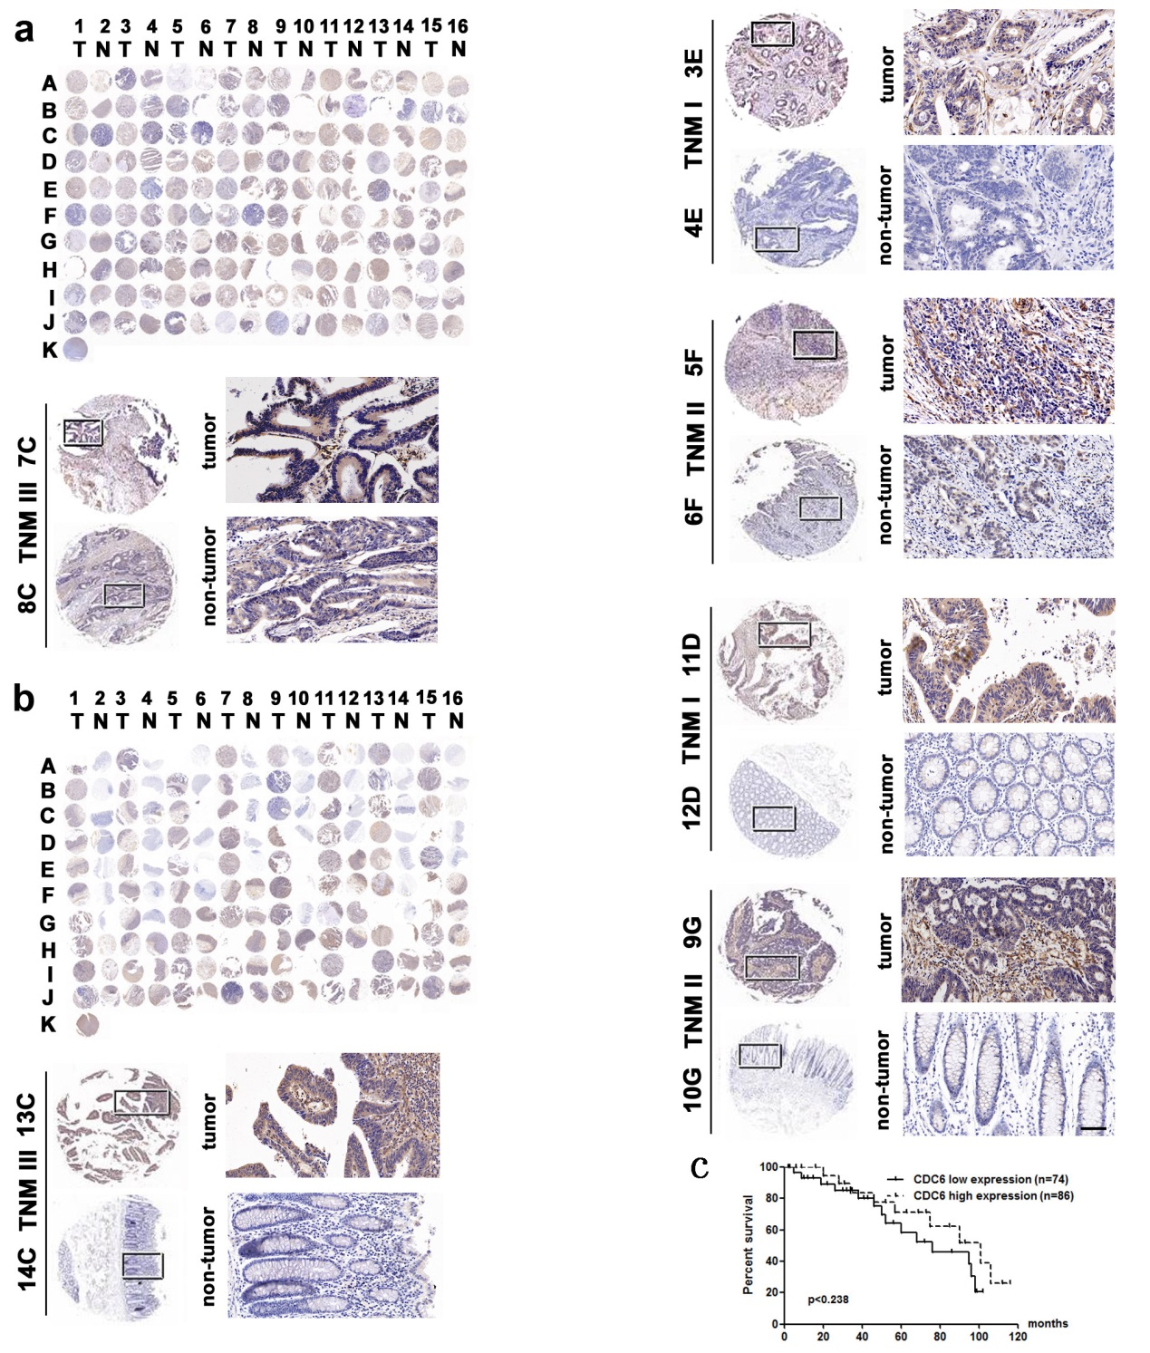
Supplementary Figure S2. TMA-CDC6 expression by IHC. (a, b) IHC staining of 160 pairs of human CRC tumor tissues (T) and noncancerous adjacent tissues (N) for CDC6 expression. Enlarged images of selected sample pairs are also shown. scale bar 50µm. (c) The correlation between tumorous CDC6 expression and patient survival by Kaplan–Meier Log-rank test (P = 0.238).

