SUPPLEMENTARY INFORMATION

Supplementary Figure S1. Pharmacodynamic analyses of LINE1 and specific gene demethylation. A: Change in CpG site methylation of LINE-1 in PBMCs from subjects in the G+C arm (n= 49). B: Average change in CpG site methylation of LINE-1 in PBMCs from subjects in the G+C arm with at least two treatment cycles and best clinical response (n= 15). Patients with or without increased LINE-1 demethylation after cycle 1 of G+C treatment are shown on the left and right, respectively. C: Gene-specific demethylation in paired tumor biopsies from subjects in the G+C arm (n=8). BRCA1 was measured, but is not shown due to extremely low signal and no significant changes observed. Error bars represent standard error of the mean. n=number of cycles for each subject; PR=partial response; SD=stable disease.
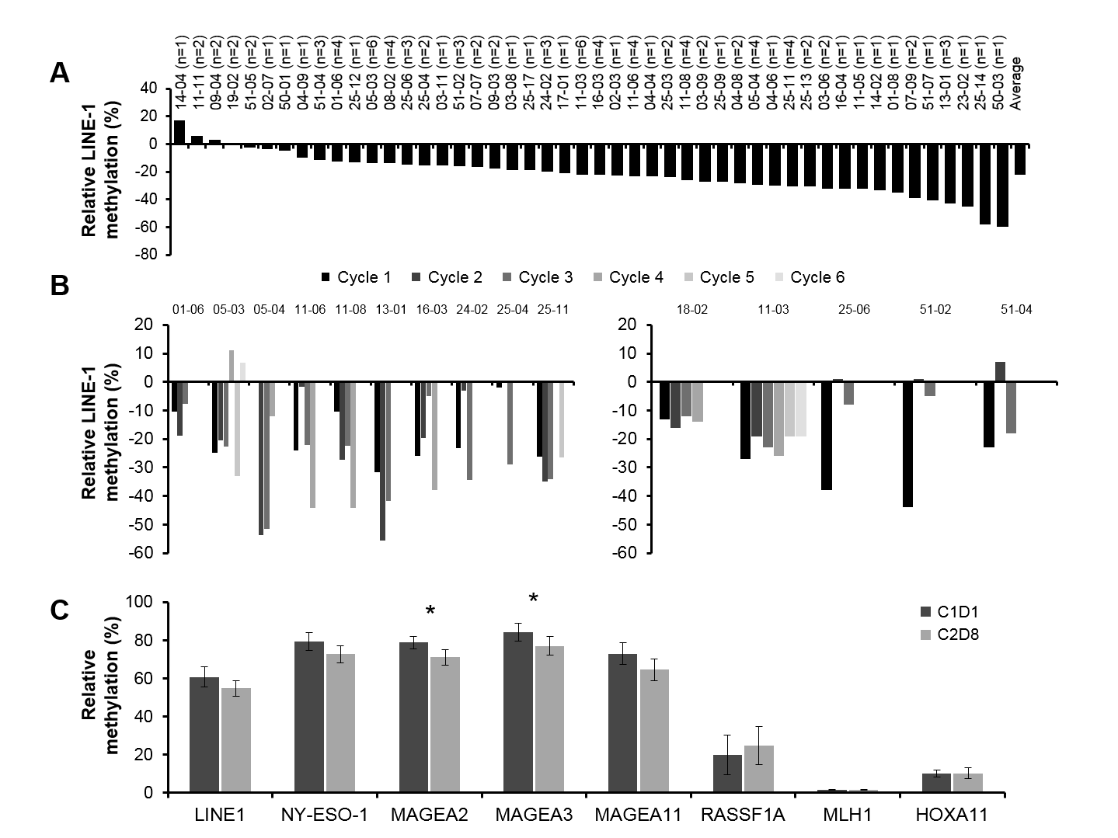

Supplementary Table S1. Genes tested for promoter methylation in tumor biopsies
Genes for methylation analysis
MAGEA2
MAGEA3
MAGEA11
RASSF1A
NY-ESO-1
MLH1
BRCA1
HOXA11

Supplementary Table S2. Summary of CA-125 reduction#
 | G+Cª  (n=51) |  | TC  (n=49) |  | Crossover  TC to G+Cª  (n=27)
Patients with Best Post-baseline CA-125 Percent
Reduction ≥ 50%
n (%) | 15 | (36)^{b} | 13 | (32)^{b} | 6 | (29)^{b}
(95% CI) | (21.6, 52.0) |  | (18.1, 48.1) |  | (11.3, 52.2)
Best (Most Reduced) Percent Change From Baseline
n | 42 |  | 41 |  | 21
Mean | -25.02 |  | -5.06 |  | -22.45
SD | 63.58 |  | 74.63 |  | 40.18
SE | 9.81 |  | 11.66 |  | 8.77
Median | -43.16 |  | -10.15 |  | -32.16
Min | -97.6 |  | -98.3 |  | -97.3
Max | 153.8 |  | 247.8 |  | 53.0
# Assessed in all patients who had a CA125 > 70 or 2XULN (includes both patients with detectable and measurable disease)
ªGuadecitabine 30 mg/m² on Days 1-5 and carboplatin AUC 4 on Day 8 of 28-day treatment cycles.
^{b}Percentages are based on a denominator of 42, 41, and 21 subjects in the G+C, TC, and TC crossover groups, respectively who had a CA125 > 70 or 2X ULN.

Supplementary Table S3: Patient disposition and reason for subject discontinuation of trial treatment

Patient Disposition | G+Cª  (n=51) |  | TC  (n=49) |  | Crossover  TC to G+Cª  (n=27)
Patients Enrolled/Randomized/Treated^{b} | 51 |  | 49 |  | 27
Patients treated (Safety data set) | 51 | (100) | 49 | (100) | 27 | (100)
Efficacy analysis data set | 51 | (100) | 49 | (100) | 27 | (100)
Reason for treatment discontinuation
Disease progression | 41 | (80) | 39 | (80) | 21 | (78)
AE | 3 | (6) | 3 | (6) | 2 | (7)
Patient decision | 2 | (4) | 2 | (4) | 0
Investigator discretion | 3 | (6) | 2 | (4) | 2 | (7)
Other | 2 | (4) | 3 | (6) | 2 | (7)
Trial discontinuation
Withdrawal of consent | 1 | (2) | 2 | (4) | 0
Death | 43 | (84) | 18 | (37) | 22 | (81)
Lost to follow-up | 0 |  | 0 |  | 1 | (4)
Database lock | 7 | (14) | 2 | (4) | 4 | (15)
ªGuadecitabine 30 mg/m² on Days 1-5 and carboplatin AUC 4 on Day 8 of 28-day treatment cycles.
^{b}Three subjects (07-06 randomized to G+C, and 05-05 and 11-01 randomized to TC) were enrolled but not treated and are not included in the table.

