Table S4: CTC biomarker group incidence by PSMA optimal cutoff (AR-v7, chromosomal instability (CIN), and neuroendocrine (NE) at baseline (N=97) and progression (N=57).

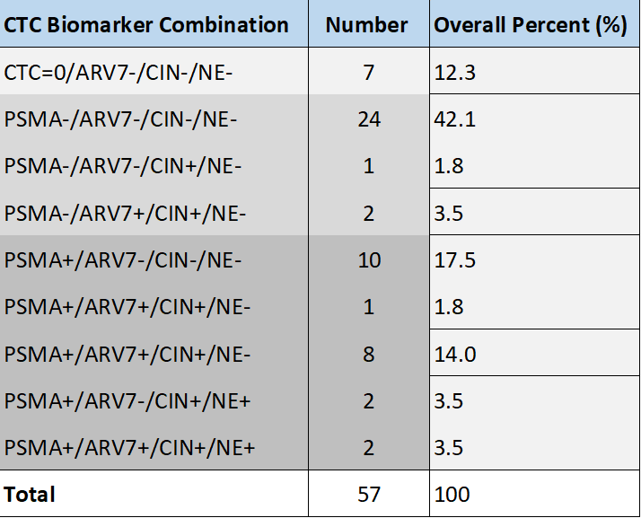
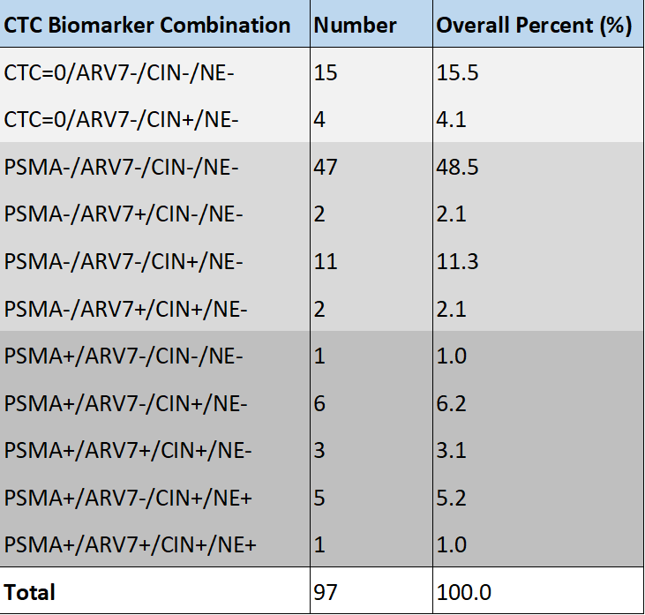
Progression
Baseline

