**Supplementary material**

S1. *Computational procedure*

The computational procedure to simulate the model is summarized in the flowchart presented in Fig. S1.



**Figure S1.** Flowchart summarizing computational procedure for simulating the model.

S2. *Calculating homing distribution of activated T cell*

We assume that there are *N* metastatic sites present in the system. Each metastatic site *i* is described by its volume (*Vi*) and organ (*Oi*) in which it is located. Each organ has a given volume (*VO*) and specific blood flow fraction (*BFFO*). Each organ is located in one of four distinct compartments (*COMP*s): 1) lung (LU), 2) liver (LI), 3) gastro-intestinal tract and the spleen (GIS), and 4) other systemic organs (SO). Let us consider a T cell activated in the lymph node that drains the jth tumor site located in organ Oj. When it enters a given compartment it has a certain probability of extravasation (HCOMP, specific for each compartment). We assume that HCOMP is the sum of probabilities of extravasation at each metastatic site (Pij) present within the given compartment

,

where



If the metastatic site *i* is located in the same organ as the metastatic site *j,* i.e. Oi = Oj, we set h = ha, and *h* = *hn* otherwise (1 ≥ *ha* > *hn*). Let us denote by WCOMP the probability that T cell will extravasate in the compartment COMP after entering the blood circulation from lymphatic system. Then the probability that a T cell activated at site *j* will extravasate at site *i* (ωij) is given by

.

We now need to derive the formula for WCOMP. In order to describe the T cell movement between the compartments we use a Markov Chain model defined by the following graph



which corresponds to the following transition matrix

,

where *I* is the identity matrix and

,

.

Extravasation at one of the compartments is represented as a transition of a T cell to one of the absorbing states (ACOMP). The parameters BFFCOMPdescribe the fraction of blood flow to a given compartment (BFFLI + BFFGIS + BFFSO = 1). The above Markov Chain is absorbing and the T cell will eventually extravasate in one of the compartments (1). The probability of being absorbed by the *j*th absorbing state when starting from *i*th non-absorbing state is the (*i*,*j*)th element of the matrix

.

Since the newly activated T cell enters the lung compartment first, we need only to calculate the first row of the matrix B. After simple calculations we obtain the following expression for the probabilities of extravasation at a given compartment



where

.

We are also interested in how many cycles in the blood system a T cell performs on average before extravasation. The average number of times that the *j*th non-absorbing state is visited when starting from *i*th non-absorbing state is equal to the (*i*,*j*)th element of matrix N (1). As the number of performed cycles is the same as the number of times the T cell enters the LU compartment minus one and LU is the initial state of the model, we need to calculate the (1,1) element of *N*. After simple calculations we obtain the following average number of cycles before absorption



S1. *Tumor-immune system interactions model*

Due to its assigned large proliferation rate (see Table 1 in main text), a single tumor site in the lung without a pre-existing breast tumor would escape immune surveillance and grow close to its imposed carrying capacity (Figure S2).

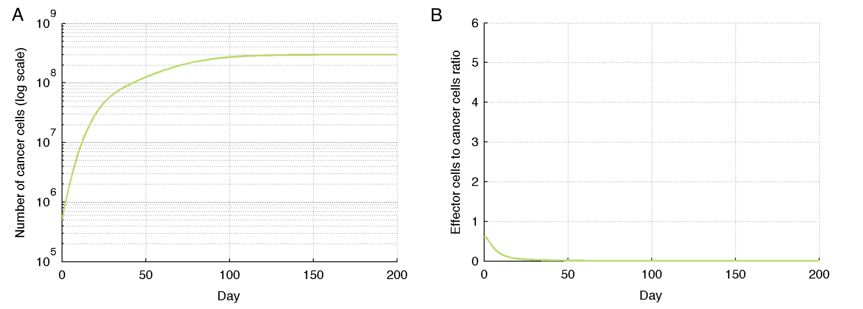

**Figure S2.** Simulation of primary lung cancer growth (Eqns. (A) and (B) in the main text). Due to a fast growth rate, the tumor quickly outgrows the effector cell population and grows close to the imposed carrying capacity. A. Temporal evolution of cancer cells. B. Temporal evolution of effector cell to cancer cell ratio.

**References**

1. Kemeny JG, Snell JL. Finite Markov chains. New York: Springer-Verlag; 1976. ix, 210 p. p.