Supplementary Materials and Methods
Generation of transgenic mouse lines, genotyping and tissue analysis
The murine pri-miR-211 sequence was ampliﬁed from the C57BL/6 mice genomic DNA (Supplementary Table S4) and cloned into an EGFP vector (13). The EGFP-miR-211 fragment was subcloned to pK14-AgIN2B-linker vector (13). Woodchuck hepatitis virus posttranscriptional regulatory element (WPRE) is a sequence to enhance the expression of murine pri-miR-211. HS4 is a chicken ß-globin sequence to insulate transgene from the signal interferences of surrounding host genome. The transgenic (Tg) mice were generated by pronuclear injection of 0.5 DPC (days post coitum) embryo obtained from a C57BL/6 mouse, and the Tg mouse lines were established and bred in speciﬁc pathogen-free conditions. The tongue and esophageal tissues were resected and photograhed under fluorescence, and exophytic lesions on the tongue surface were counted. After fixation of the tissues with formalin, the esophagi were opened to quantify the surface area being occupied by exophytic lesions. The tissues were then processed for histopathological examination, immunohistochemistry and in situ hybridization analysis (13). To analyze gene expression in pure epithelium using Western blot analysis, the squamous epithelium were stripped from tongue, esophagus and skin tissues using the protocol we established (15). All animal studies were done in accordance with the guideline of National Yang-Ming University Institutional Animal Care and Use Committee (IACUC).
Quantitative (q)RT-PCR
Total RNA was reversely transcribed into cDNA and the gene expression was detected by TaqMan assay kits (Applied Biosystems) in Supplementary Table S3. RNU6B and GAPDH were the internal controls for miRNA expression and mRNA/primary miRNA expression (Applied Biosystems), respectively. The threshold cycle (C_{t}) method was used to measure the relative changes in expression. Data were analyzed using the –ΔΔC_{t} method and values calculated relative to internal controls (11).
Western blot analysis
The Western blot analysis followed protocols we previously used (15). The primary antibodies are listed in Supplementary Table S8. Signals were revealed by Western Lightening Chemiluminescence Reagent Plus kit (Perkin-Elmer, Waltham, MA) and detected using Fusion SL imaging system (Viber Lourmat, Marne-la-Vallee, France). Numbers below pictures, normalized values.
Reporter plasmids and assays
The region of 3’untranslation region (3’UTR) sequence of the tumor-associated genes CDH4, HAS2, KLLN, TCF4, TCF12, TGFbRII, and UBA2 that encompassed the predicted miR-211 binding site was amplified by PCR (Supplementary Table S4). The amplicons were cloned into the pMIR-REPORTTM luciferase reporter vector (Applied Biosystems) to produce a wild-type (wt) reporter construct. The TCF12 mutant (mut) reporter construct was obtained from the wt construct by replacing the original sequence AAAGGG at the target site with GAGCUC in order to create a new SacІ restriction enzyme digestion site (Supplementary Table S9).
The putative promoter region from -57 to -943 of FAM213A gene amplified from human genomic DNA (Supplementary Table S4) was cloned into the Mlu1 and Xho1 site of the pGL3-basic vector (Promega, Madison, WI). Firefly luciferase activity normalized to renilla luciferase activity, which was used to represent transfection efficiency, represents reporter or promoter activity.
Subcellular fractionation
Nuclear and cytosolic fractions were prepared using the CNM Compartment Protein Extraction kit (BioChain, Hayward, CA) following the manufacturer’s protocols.
Immunohistochemistry (IHC)
Formalin-fixed paraffin embedded tissues were sectioned and processed for IHC using the protocols we previously published (11). The primary antibodies are listed in Supplementary Table S8. The cytosolic immunoreactivities were acquired by Image J software (NIH, Bethesda, MD) and the signal pixels were scored using Photoshop software (Adobe, San Jose, CA) (42). The nuclear immunoreactivity was scored according to the percentage of positive nuclei in total nuclei.
In situ hybridization (ISH)
ISH was performed by using miRCURY LNATM microRNA ISH Optimization Kit (Exiqon, Copenhagen, Denmark), the hsa-miR-211, mmu-miR-211 probes and scramble probe (control). Formalin-fixed paraffin embedded tissues were sectioned and processed for ISH following the protocols we previously published (46). The blue miR-211 staining were captured and quantiﬁed using the same methods being used for IHC quantitation.
Bioinformative annotation
The data achieved from GeneChip analysis were imported to GeneSpring software (Agilent, Santa Clara, CA) using a cut-off value≧ 2 to retrieve potential genes. The functions and interaction networks of selected genes were analyzed by Ingenuity Pathway Analysis (IPA) (http://www.ingenuity.com). The predicted binding sites from the upstream of transcription start site (TSS) 1000 nucleotides to TSS (-1000-TSS) in each gene acquired from Jaspar database is reported if the sites occurring in human and/or mouse TCF12 binding sequences surpass a threshold score of 80%. The prediction score represents the extent of total E-box motifs in -1000-TSS.
Chromatin immunoprecipitation (ChIP) assay
ChIP assays were carried using EZ-ChIPTM (Cat#17-371; Millipore, Billerica, MA). The chromatin was sonicated and immunoprecipitated using an antibody against TCF12 (Supplementary Table S8). The immunoprecipitated chromatin was analyzed by amplification of the nt -608 to -792 region in the FAM213A promoter using PCR. Primers are shown in Supplementary Table S4. The amplicons were resolved on a 1.5% agarose gel and visualized by an imaging system (Viber Lourmat). Side-by-side SYBR® Green quantitative (q)PCR analysis was also performed for quantitation.
ROS assay
To detect the intracellular ROS levels, cells were re-suspended in 2% PBS, challenged with 1 mM hydrogen peroxide (H₂O₂) at 37°C for 30 minutes, then stained with 25 µM 5-(and-6)-chloromethyl-2',7'-dichlorodihydrofluorescein diacetate (CM-H₂DCFDA; Invitrogen, Carlsbad, CA) at 37°C for 30 minutes in the dark. The subtraction of background fluorescence as measured in the unstained controls from fluorescence values obtained represents the ROS level.
Oxidative stress detection
The oxidation of proteins in cells was analyzed using the Oxidized Protein Western Blot Kit (Abcam, Cambridge, MA) according to the manufacturer’s protocols. The analysis detected protein oxidation measured as carbonyl-containing 2, 4-Dinitrophenylhydrazine (DNPH) adducts by adding DNPH in reaction. The analysis without adding DNPH served as control. Using the reagents and protocol provided, protein carbonyls in tissue sections were assayed using immunohistochemical labeling. The oxidative DNA damage in tissues was determined by nuclear immunoreactivity of 8-hydroxy-2’-deoxyguanosine (8-OHdG) (Supplementary Table S8).

Supplementary Tables
Table S1. Cell cultivation conditions
 | Culture medium | Supplementary ingredients
SAS | DMEM | 10% FBS +1% pen-strep-ampho + 2 mM L-glutamine
OECM1 | RPMI1640 | 10% FBS +1% pen-strep-ampho
HSC3 | DMEM/F12 | 10% FBS +1% pen-strep-ampho
FaDu | MEM | 10% FBS +1% pen-strep-ampho +2 mM L-glutamine
OC4 | KSFM | 33% complete DMEM
SCC25 | DMEM/F12 | 10% FBS +1% pen-strep-ampho
293T | DMEM | 10% FBS +1% pen-strep-ampho
phoenix | DMEM | 10% FBS +1% pen-strep-ampho +2 mM L-glutamine
YMOCs | αMEM | 16% FBS +1% pen-strep-ampho

Table S2. siRNAs used in the present study
siRNA | Supplier | Cat. No.
siTCF12 | Dharmacon | L-006356
Scr | Dharmacon | D-001810
siFAM213A | Santa Cruz Biotch | sc-90705
Scr | Santa Cruz Biotech | sc-37007

Table S3. TaqMan® assay probes used in the present study
Gene and miRNA | Cat. No.
ABCA1 | Hs01059118_m1
CDH4 | Hs00242399_m1
CLCA2 | Hs00998916_m1
FAM213A | Hs00800009_s1
GAPDH | Hs02758991_g1
GDF15 | Hs00171132_m1
HAS2 | Hs00193435_m1
hsa-miR-211 | 000514
KLLN | Hs03644985_s1
mmu-miR-211 | 001199
NNMT | Hs00196287_m1
hsa-pri-miR-211 | Hs03302954_pri
RNU6B | 001093
TCF4 | Hs00162613_m1
TCF12 | Hs00918966_m1
TGFβRII | Hs00234253_m1
TNFSF10 | Hs00921974_m1
TRIM29 | Hs00232590_m1
U6 snRNA | 001973
UBA2 | Hs00271420_m1

Table S4. Primers used in the present study
Gene or construct | Direction | Sequences (5’ - 3’) | Amplicon (bps)
CDH4 reporter | Forward | CCCACTAGTCCTGCATGAGCACAGTTGTT | 251
 | Reverse | CCCACGCGTCTCCGCAAGGGTCTACTGAG
ChIP assay | Forward | CCCCAAGTGTTGCTGTAAGTTT | 185
 | Reverse | ATAAGGTGAAGTGGCAAAGCAG
FAM213A promoter activity assay | Forward | GGGACGCGTCTGATCTCCCTTACCCCACA | 887
 | Reverse | GGGCTCGAGCGTGCCTGTATTTCCAGCTA
HAS2 reporter | Forward | CCCACTAGTCCCAAAATGTGAAGCTTGGT | 375
 | Reverse | CCCACGCGTGGGAAAACACTGCCAGAATC
HS4 | Forward | CCTCCTTGGGCAACCTGTTCAG | 654
 | Reverse | ATGTGGCACTGAGGGACATGGC
KLLN reporter | Forward | CCCACTAGTGCCCGGCCATACTTAGTTCT | 250
 | Reverse | CCCACGCGTGCTGGTCATTTCGCTTATCA
mmu-pri-miR-211 | Forward | CCGGGATCCCCTCATGCTGGAATACTGACC | 302
 | Reverse | CCGGGTACCGCGTGCTTGGGATTTTTACATC
TCF4 reporter | Forward | gggACTAGTCATTAAAAACTTAAAAAAATTG | 83
 | Reverse | gggACGCGTaaggtgtaactgtttatc
TCF12 CDS | Forward | CCCCGGATCCgctagaagtggccgaagatg | 2250
 | Reverse | CCCCCGTCGACccctcctgtcaggtttgtgt
TCF12 mut reporter  and  TCF12 MUT | Forward | CTGTAAGGTCTACATATGAGCTCAAAGTTAATGTGGAAAGC | For amplification of internal fragment
 | Reverse | GCTTTCCACATTAACTTTGAGCTCATATGTAGACCTTACAG
TCF12 WT | Forward | CCCCGGATCCgctagaagtggccgaagatg | 4496
 | Reverse | CCCCCGTCGACaaaaagatggcacatttattgct
TCF12 wt reporter | Forward | gggACTAGTccgtggaagttgccttgtg | 725
 | Reverse | gggACGCGTtgtgcttacttacagctaacact
TGFβRII reporter | Forward | CCCACTAGTTCAAGAAAAAAGACCAAG | 149
 | Reverse | CCCACGCGTGTATATAGCATTCACATTC
UBA2 reporter | Forward | CCCACTAGTTGCCTCTAAACAGAACCCTCTT | 256
 | Reverse | CCCACGCGTGGCAACATGCATTGTGTTGT

Table S5. shRNA clones used in the present study
 | Clone ID | Clone Name
shLuc | TRCN0000072249 | Promega_Luc_976s1c1
shTcf12 (b4) | TRCN0000015168 | NM_003205.3-3410s1c1
shTcf12 (b5) | TRCN0000015169 | NM_003205.3-986s1c1

Table S6. Paired OSCC samples for qRT-PCR
and Western blot analysis
n = | 50
Age (mean ± SE) | 57.9 ± 1.4
Gender (Male/Female) | 46/4
T1-3 | 18
T4 | 32
N0 | 32
N+ | 18
Stage I-III | 17
Stage IV | 33

Table S7. OSCC samples in TMA for IHC and
ISH analysis
n = | 49
Age (mean ± SE) | 56.9 ± 1.7
Gender (Male/Female) | 45/4
T1-3 | 12
T4 | 37
N0 | 33
N+ | 16
Stage I-III | 12
Stage IV | 37
Relapse or new lesion | 26
Disease-free | 23
Death | 20
Alive | 29

Table S8. Primary antibodies or associated reagents used in the present study
Antibody | MW (kDa) | Host | Dilution | Supplier | Cat. No.
α-Tubulin | 50 | mouse | 1:5000 | Sigma-Aldrich | t51681
Bax* | 23 | rabbit | 1:100 | Santa Cruz Biotech | sc-526
Bcl-2* | 26 | mouse | 1:100 | Santa Cruz Biotech | sc-7382
Bcl-xS/L* | 30/18 | rabbit | 1:100 | Santa Cruz Biotech | sc-634
β-actin | 43 | mouse | 1:4000 | Cell Signaling | 3700
FAM213A | 22 | rabbit | 1:200 | Sigma-Aldrich | HPA009025
FAM213A* | 22 | rabbit | 1:100 | Sigma-Aldrich | HPA009025
GAPDH | 36 | mouse | 1: 10000 | Santa Cruz Biotech | sc32233
GFP* | 27 | mouse | 1:100 | Clontech | 632381
Histone H3 | 17 | rabbit | 1:1000 | Cell Signaling | 9715s
IgG# |  | rabbit | 1:20000 | Sigma-Aldrich | R1131
Ki67* | 359 | rabbit | 1:200 | Abcam | ab15580
K14* | 55 | mouse | 1:200 | Abcam | Ab7800
TCF4 | 71 | rabbit | 1:500 | Abcam | 2114-S
TCF12 | 85 | rabbit | 1:1000 | Santa Cruz Biotech | sc-357
TCF12# | 85 | rabbit | 1:40-80 | Santa Cruz Biotech | sc-357
TCF12* | 85 | rabbit | 1:50 | Santa Cruz Biotech | sc-28364
TGFβRII | 63 | rabbit | 1:1000 | Cell Signaling | 3713
TRIM29 | 65 | rabbit | 1:1000 | Abcam | Ab22207
8-OHdG* |  | mouse | 1:100 | Abcam | Ab48508
* IHC; #ChIP; others, Western blot analysis

Table S9. The complimentarity between miR-211 and the 3’UTR
of TCF12 gene
TCF12 3’UTR and miR-211
TCF12 Wt 3'UTR 5’GUAAGGUCUACAUAUAAAGGGAAAAAG
| | | | | | | |
miR-211 3’ UCCGCUUCCUACUGUUUCCCUU 5’
| | |
TCF12 Mut 3'UTR 5’ GUAAGGUCUACAUAUGAGCUCAAAAG

Table S10. Jaspar prediction scores
Gene symbol | Score | Gene symbol | Score | Gene symbol | Score | Gene symbol | Score
ABCA1 | 20.9 | FBXO32 | 45.9 | PADI3 | 46.7 | TUBA1A | 10.1
ANXA10 | 8.6 | GDF15 | 65.2 | SRPX2 | 26.6 | UNC5B | 31.5
CEBPD | 27.3 | IL20RB | 12.1 | TET1 | 38.8 | XCL1 | 21.5
CLCA2 | 21.8 | MUC1 | 43.7 | TNFSF10 | 36.8 | XCL2 | 17.1
CXCL2 | 33.4 | NAMPT | 19.5 | TNS1 | 17.8 | CST6 | 44.0
EHF | 28.5 | NFKBIZ | 12.2 | TPRG1 | 45.2 | GPRC5B | 43.9
FAM213A | 33.3 | NNMT | 57.9 | TRIM29 | 92.5 | PSG4 | 28.2

Supplementary Figures
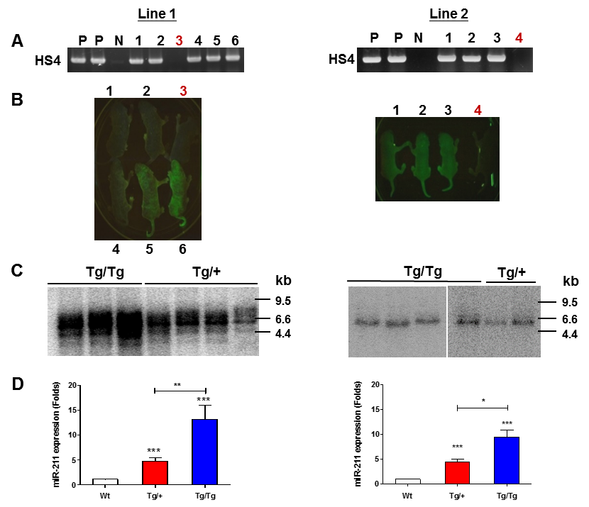

Fig S1. Genotyping of K14-EGFP-miR-211 transgenic mouse model. Lt and Rt, Line 1 and Line 2 Tg mouse lines, respectively. (A) PCR analysis; (B) Fluorescence image; (C) Southern blot analysis; (D) qRT-PCR analysis. (A) PCR analysis of HS4 gene using mouse tail DNA. Except for the Wt mice marked with brown numbers, all the remained mice are HS4 positive Tg mice. P, positive control; N, negative control. (B) Fluorescence images of infant mice confirm that Tg mice display green fluorescence on skin, while the Wt mice (marked with brown numbers) lack such fluorescence. The fluorescence is stronger in homozygous mice than in heterozygous mice. (C) Analysis of mouse tail DNA using HS4 as probe reveals that Line 1 mice have higher copies of transgene integration than Line 2 mice. Homozygous (Tg/Tg) mice have higher copies of transgene than heterozygous (Tg/+) mice. (D) qRT-PCR analysis of miR-211 using mouse ear RNA. It discloses an increased miR-211 expression following the increase of transgene dosage. The expression level of transgenic miR-211 in these two lines are about the same. The miR-211 expression in ear tissue of homozygous mice is about 2-fold the heterozygous mice in both lines. Un-paired t-test.
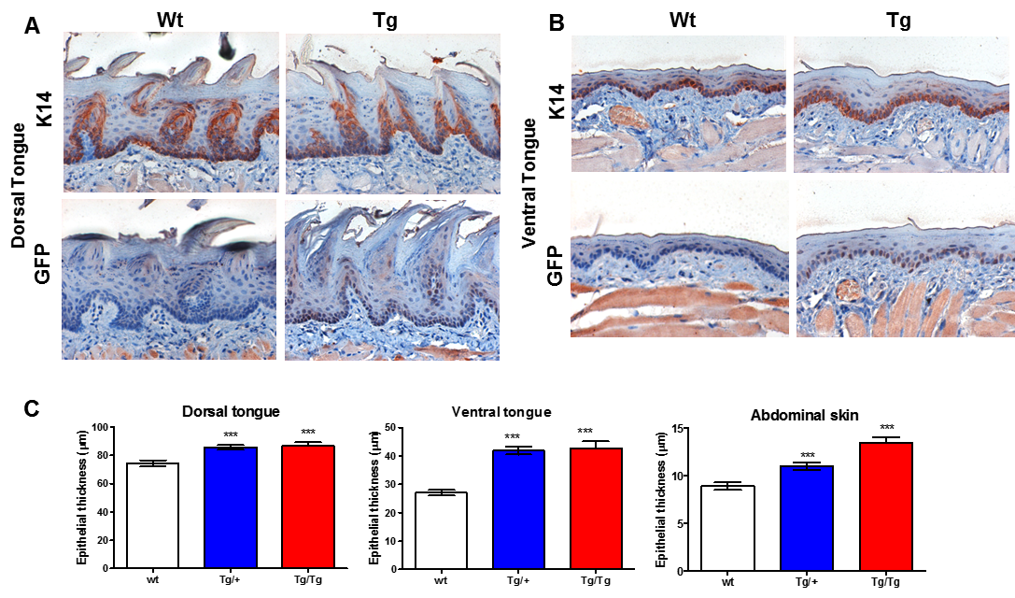

Fig S2. GFP immunoreactivity and thickness in squamous epithelium. (A, B) IHC staining of K14 (Upper) and GFP (Lower) in dorsal and ventral tongue, respectively. Wt, wild-type mice; Tg, transgenic mice. (100x or 200x). It reveals the presence of GFP immunoreactivity in the basal or the parabasal epithelial cells in both dorsal and ventral tongue of Tg mice, while it is absent in Wt mice. (C) Quantitation of the epithelial thickness of dorsal tongue (Lt), ventral tongue (Middle) and skin (Rt). The measurement of the thickness are at 50 μm intervals. At least 40 individual measurements are carried out in each setting. The results indicate an increase of epithelial thickness in Tg mice following the increase of transgene dosages. Un-paired t-test.

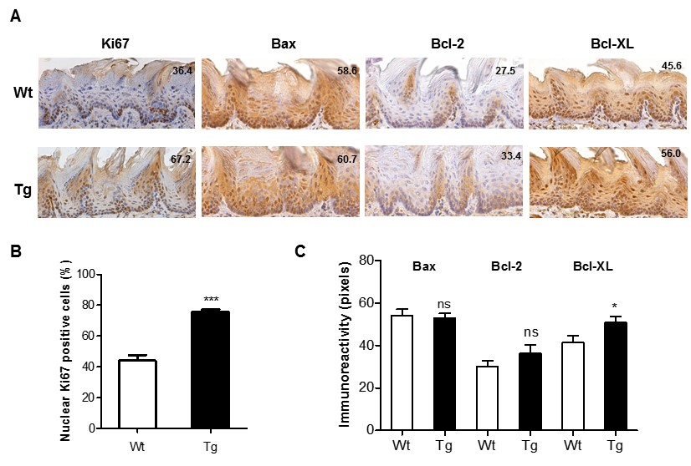

Fig S3. Immunohistochemistry of the cell proliferation and survival proteins in tongue epithelium. (A) IHC staining of Ki67, Bax, Bcl-2 and Bcl-xL in dorsal tongue. (200x). (B) Quantitation of nuclear Ki67 immunoreactivity. (C) Quantitation of Bax, Bcl-2 and Bcl-xL immunoreactivities. The results indicate a significant increase of Ki67 and Bcl-xL expression in the tongue epithelium of Tg mice. Numbers in pictures are pixel scores or counted percentages. Wt, wild-type mice; Tg, transgenic mice. Un-paired t-test.

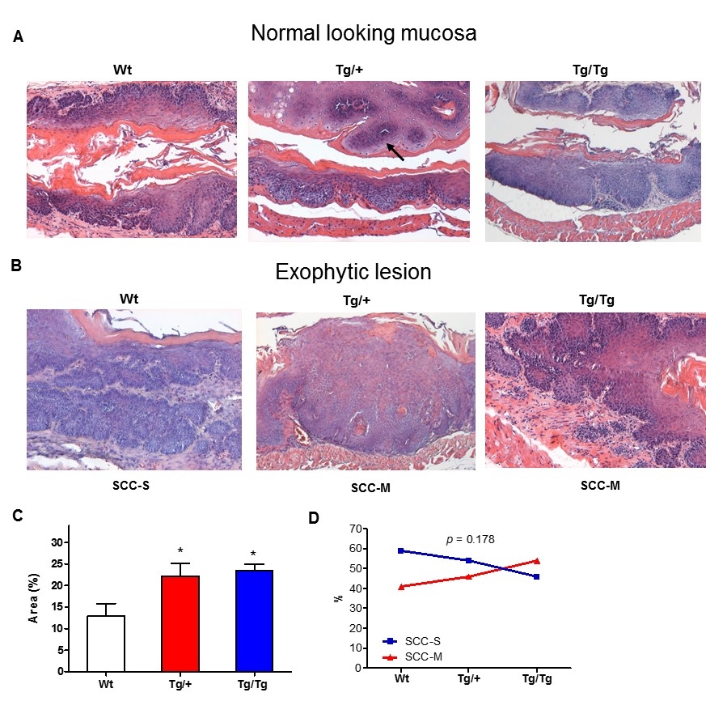

Fig S4. Induction of mouse esophageal tumorigenesis by 4NQO. (A, B) Histopathology. (x100). (A) Normal looking mucosa. (B) Exophytic lesion. (A) The histopathological sections of esophageal mucosa show an extensive epithelial dysplasia with different degrees of severity. The spaces in the middle of epithelial layers are the esophageal lumen. An arrow indicates an exophytic SCC in the opposite side of an esophageal mucosa with moderate epithelial dysplasia. (B) Sections of exophytic lesion show SCC with stromal invasion (SCC-S) or muscle involvement (SCC-M). (C) Quantitation of the lesion area (%) on esophageal surfaces. Representative gross pictures are in Fig. 1A, c. (D) Quantitation of the severity of SCC invasion. Although 4NQO induces remarkable filed cancerization of esophageal epithelium (in A), enrichment of tumor number induction in accordance with the miR-211 expression is noted. However, the invasiveness of esophageal SCC in Tg mice does not seem different from that in Wt mice. Wt, wild-type mice; Tg, transgenic mice. Un-paired t-test or X² test.
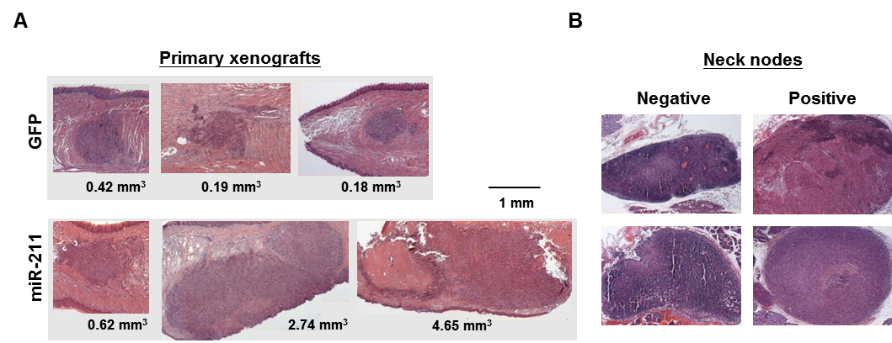

Fig. S5. Representative histopathological sections of orthotopic xenografts and neck lymph nodes. (A) Tongues. (B) Neck lymph nodes. Numbers illustrate the size of tumors in tongue.

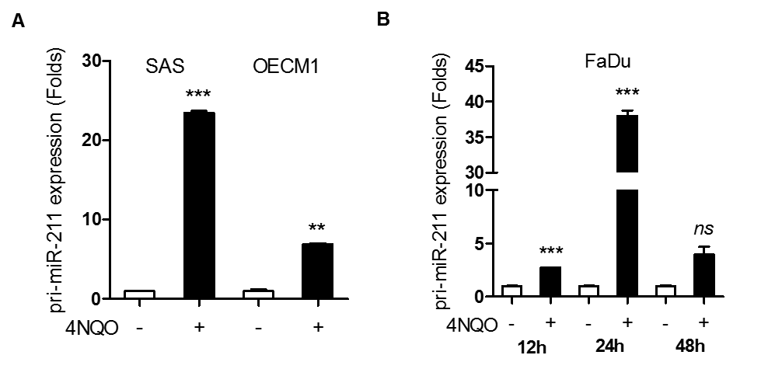

Fig. S6. Analysis of pri-miR-211 expression in OSCC cells. OSCC cells are treated with 4NQO for 48 h (in A) or various time periods (in B). The qRT-PCR analysis shows the up-regulation of pri-miR-211 to various degrees in different cells. The increase of pri-miR-211 expression is correlated with the increase of miR-211 in OSCC cells. Un-paired t-test.

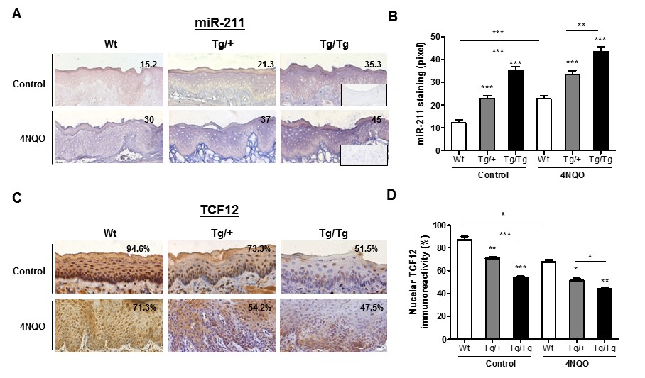

Fig. S7. miR-211 staining and TCF12 immunoreactivity in mouse tongue tissues. (A, C) Representative miR-211 staining and TCF12 immunoreactivity, respectively. Indents, ISH staining using scramble probe. (x200). (B, D) Quantitation of miR-211 pixel readings and the percentage of cells positive for nuclear TCF12 immunoreactivity in tissues. Wt, wild-type mice; Tg/+, heterozygous transgenic mice; Tg/Tg, homozygous transgenic mice. Numbers in pictures are pixel scores or counted percentages. Un-paired t-test.

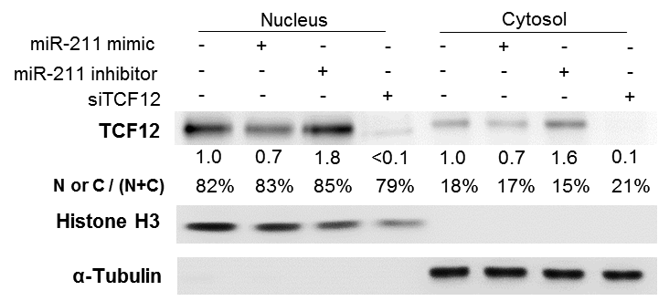

Fig. S8. Analysis of TCF12 protein in subcellular fractions in FaDu cells. Nuclear extract contains much higher abundance of TCF12 than cytosolic fraction. The ratio is more than four folds. The modulation of miR-211 on TCF12 occurs in both nucleus and cytosol. Numbers below Western blot pictures are normalized values. % designates nucleic or cytosolic ratio.

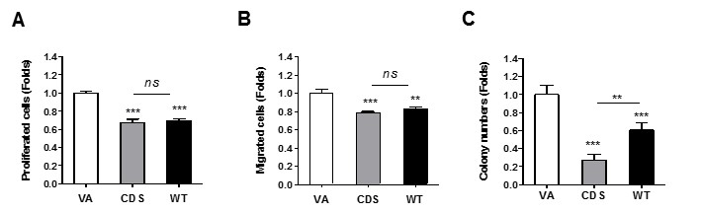

Fig. S9. Phenotypic analysis of OECM1 cell with TCF12 expression. (A) Proliferation; (B) Migration; (C) AIG. The proliferation and migration in the CDS are indifferent from those in the WT. However, the AIG capability in CDS is lower than the WT. In comparison with the phenotypic analysis in MUT shown in Fig. 3A, a and Fig. 3B, b, we consider that some neoplastic phenotypes in CDS could be resistant to TCF12 suppression in OECM1 cell line. Un-paired t-test or two-way ANOVA test.
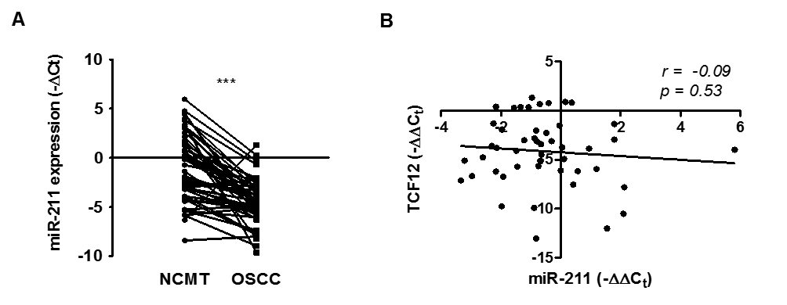

Fig. S10. Correlation between miR-211 expression and TCF12 mRNA expression in OSCC tumors. (A) Before-after plot illustrating miR-211 expression as revealed by qRT-PCR analysis in tissue pairs. A significant down-regulation is noted in OSCC tumors. paired t-test. (B) Linear regression analysis shows no correlation between miR-211 expression and TCF12 mRNA expression in OSCC tumors. The high miR-211 expression in NCMT could due to the contamination of stromal tissue, which has high miR-211 expression (details described in Fig. S11A).

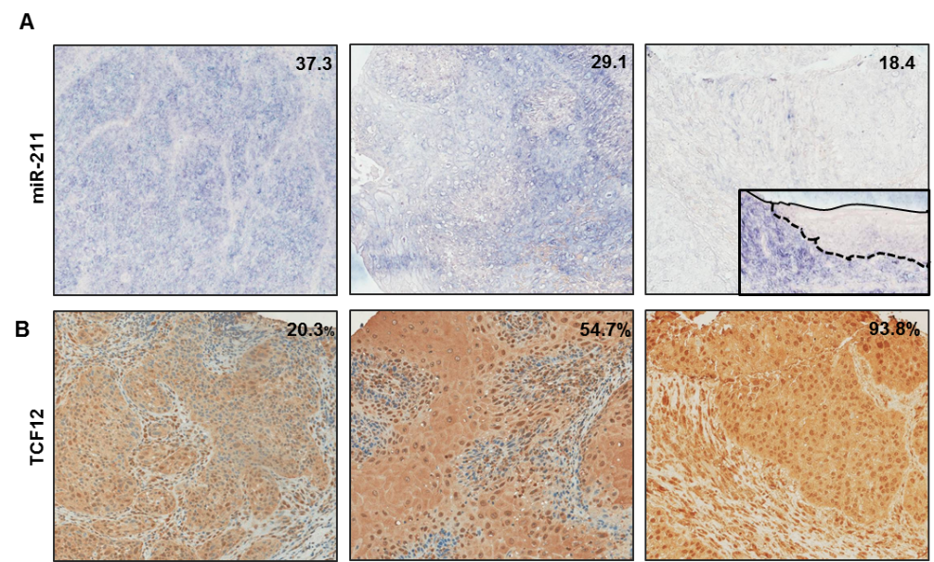

Fig. S11. miR-211 staining and TCF12 immunoreactivity in OSCC. IHC and ISH are performed in OSCC TMA. Representative miR-211 staining (in A) and TCF12 immunoreactivity (in B) in OSCC tumors. (x100). The images of the same tumor tissue core are aligned in the same row. Numbers in pictures depict miR-211 pixel readings or the percentage of cells positive for nuclear TCF12 immunoreactivity. A reverse correlation is found between the miR-211 staining and the nuclear TCF12 immunoreactivity, which is shown in Fig. 3D, c. Indent shows the paired NCMT of the tumor. It reveals barely detectable miR-211 staining in the epithelium enclosed by solid line and dot line. Whereas, the stromal tissue subjacent to the dot line displays intensive miR-211 staining. Similar findings of the stronger miR-211 staining in stromal component other than epithelial component of NCMT are also shown in Fig. 7A, Upper panels.

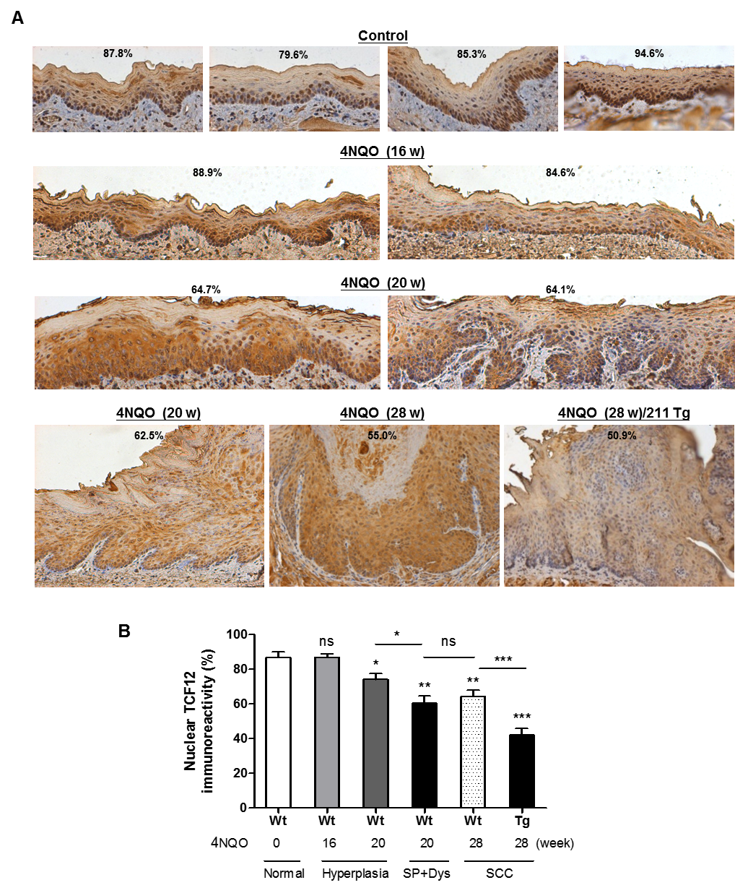

Fig. S12. TCF12 immunoreactivity in mouse multistep carcinogenesis. (A) IHC of TCF12. Mouse tongue tissues upon 4NQO treatment for different periods. (x100). Number within parenthesis, treatment week; Number in picture, percentage of positive nucleus. Except for the Rt Lowerest panel, which is from Tg mouse, all other panels are Wt mice. (B) Quantitation of nuclear TCF12 immunoreactivity across different tissues at the multistep carcinogenesis. SCP, squamous cell papilloma; Dys, moderate to severe dysplasia. Un-paired t-test.

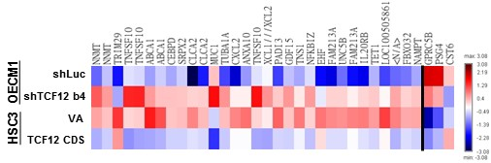

Fig. S13. Color diagram of Fig. 4A, a

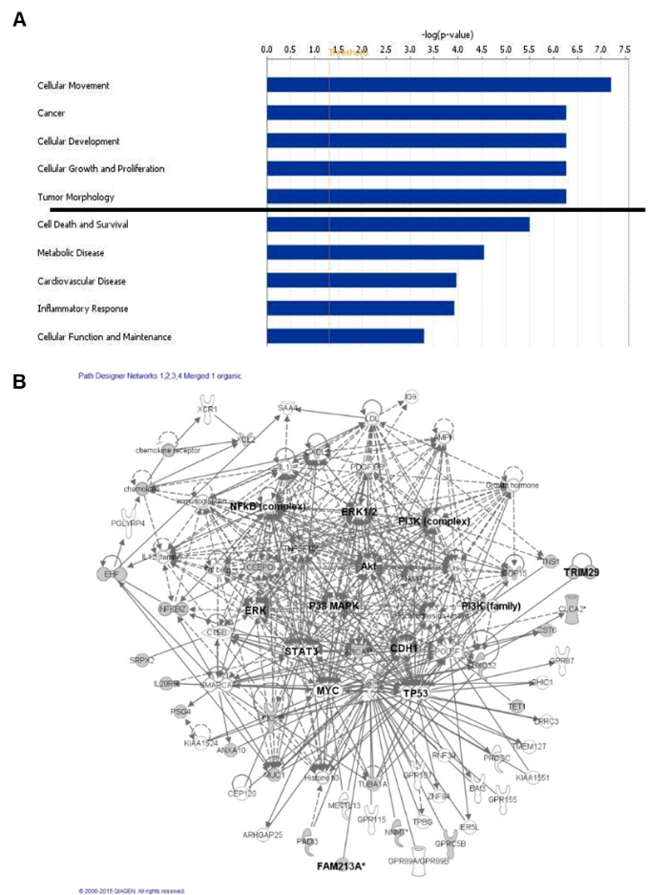

Fig S14. Analysis of TCF12 associated biological processes and gene interaction networks. Comparing to controls, 632 gene spots up-regulated in HSC3 knockdown cells and 302 gene spots down-regulated in OECM1 expression cell are found. The overlapped 31 gene spots are presumed oncogenic in the downstream. Similarly, 195 gene spots down-regulated in HSC3 knockdown cells and 161 gene spots up-regulated in OECM1 expression cell, with three suspected suppressors being overlapped. Since there are five genes exhibiting repeated appearance of spots for more than twice, a total of 28 distinctive genes are subjected to IPA. (A) Top 10 biological processes. These potential genes are preferentially involved in the regulation of cell movement, proliferation and development, as well as tumor formation and morphology, and so on. The line separates more critical processes (p<10⁻⁶) from others. (B) Network analysis. It indicates that these genes are involved in complicated interactive networks with the convergence to core node complexes consisting of, AKT, AMPK, CDH, MAPKs, myc, p53 and pTEN signaling pathways.
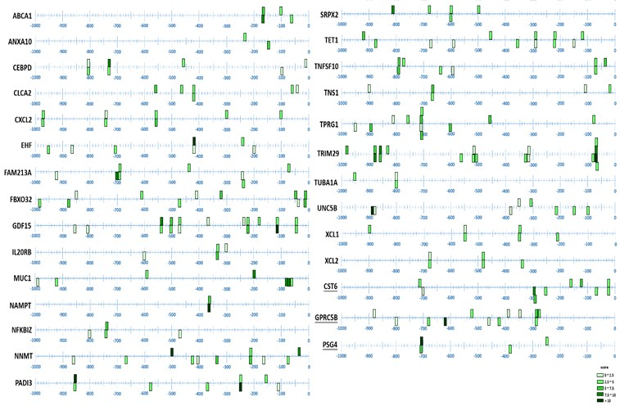

Fig. S15. Prediction of the potential regulation of TCF12 on the promoter activity of downstream genes using Jasper software. The prediction map of E-boxes in -1000-TSS region of various putative promoters. The predicted scores are represented by color gradient in boxes. The denser the color in the filled boxes designates the higher consensus to an ideal E-box motif. The bar above the sequence means predicted on sense strand; under the sequence means predicted on antisense strand.

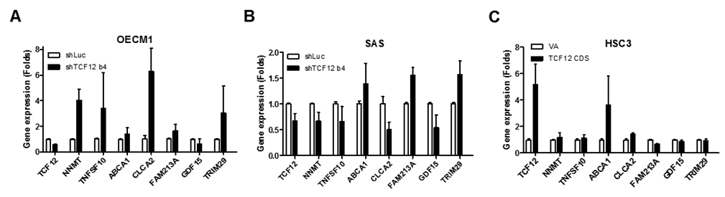

Fig. S16. qRT-PCR analysis to confirm the regulation of TCF12 on downstream genes across different OSCC cells. (A, B) OECM1 and SAS cells with TCF12 knockdown and their control, respectively. (C) HSC3 cell with TCF12 expression and its control. FAM213A and TRIM29 are consistently up-regulated when TCF12 is knocked down, and they are down-regulated when TCF12 expresses in OSCC cells.

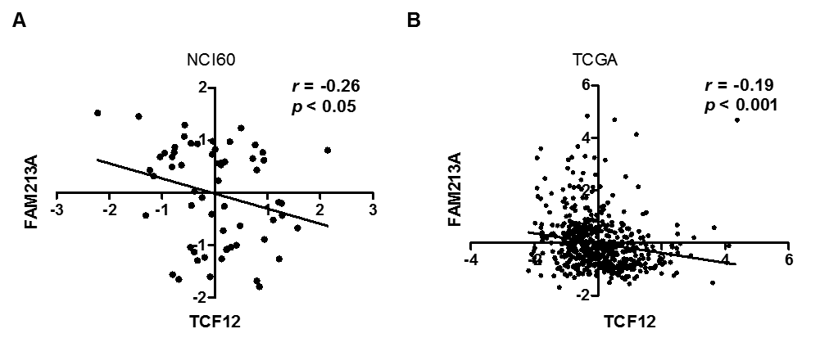

Fig. S17. Correlation between the expression of TCF12 and FAM213A in database. (A) NCI-60 cancer cell lines. (B) TCGA HNSCC database. Linear regression analysis. Lines, regression lines.

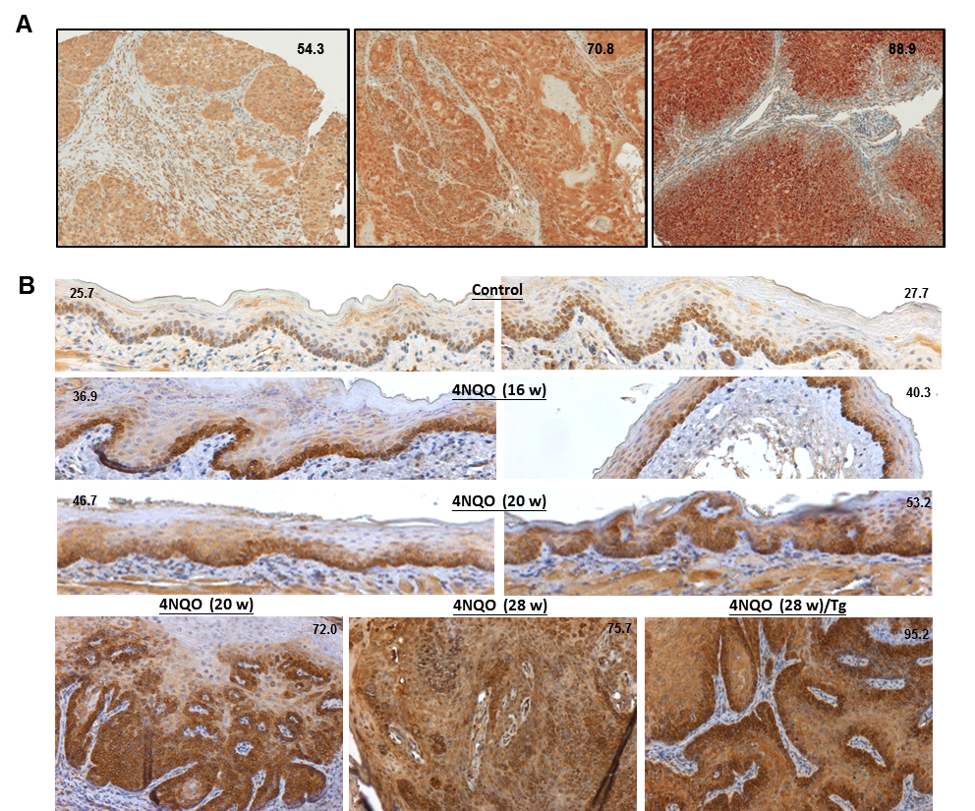

Fig. S18. FAM213A immunoreactivity. (A) Representative human OSCC tumors in TMA. (x100). (B) Mouse tongue tissues upon 4NQO treatment for different periods. (x100). Number within parenthesis, treatment week; Number in picture, pixel score. Except for the Rt Lowest panel, which is from Tg mouse, all other panels are Wt mice. Representative parts of each panel are shown in Fig. 7C, b and the quantitation is shown in Fig. 7C, d.

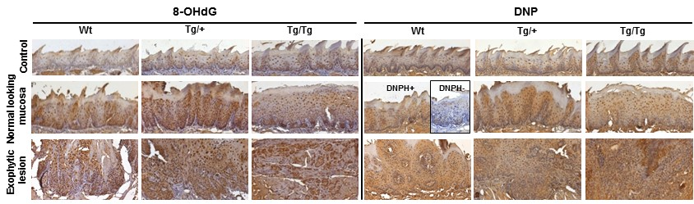

Fig. S19. Color diagram of Fig. 6D.

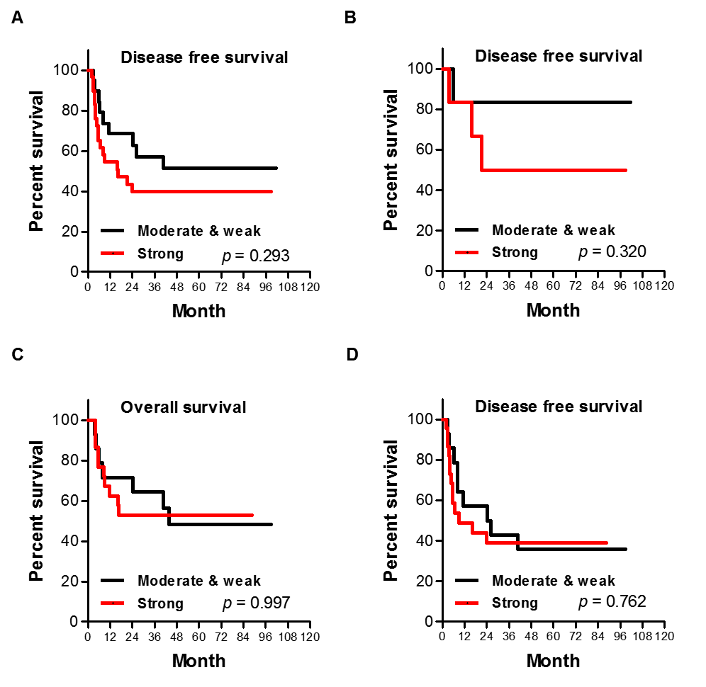

Fig. S20. Kaplan-Meier survival analysis. (A, B, D). Disease-free survival. (C) Overall survival. (A) All patients. (B) Stage I - III patients. (C, D) Stage IV patients.

